**Master**

Data Analytics for Business

**Master´s Final** **Work**

Dissertation

Supervised Clustering With SHAP Values

Rodrigo Queirós Conceição

September - 2022

**Master**

Data Analytics For Business

**Master´s Final Work**

Dissertation

Supervised Clustering with SHAP Values

Rodrigo Queirós Conceição

**Supervision:**

João Afonso Bastos

September - 2022

This is just a blank page. Please delete all the comments (like this one) when you start writing your Master’s Final Work (MFW). However, do not forget to leave a blank paragraph here; otherwise, you delete the section and you mess the page numbers up.

You can use this page for a dedication. See the example below.

To all my master’s students that started a dissertation under my supervision, but were abducted by extra-terrestrials or crossed to another dimension.

# Erratum

Use this section only if you need to include an erratum. This only makes sense for a MFW that passed without any changes in the *viva voce* examination. Otherwise, you should delete this section.

Please find below the example of a paragraph in an erratum:

1. In page 23, third line of second paragraph, it is written “the curve shifts rightwards” instead of “the curve shifts leftwards.”

# Glossary

Here you should list expressions and acronyms that will be used all over the text. They should be listed alphabetically.

Please find some examples below:

GDP – Gross Domestic Product.

JEL – Journal of Economic Literature.

MFW – Master’s Final Work.

OLS – Ordinary Least Squares.

# Abstract, Keywords and JEL Codes

Write your abstract in 300 words or less. You should set the problem, say how you tackled it, and what the main conclusions were.

Here is an example of an opening period:

This dissertation provides new insights on the estimation of mark-up ratios in Portugal, using annual panel data for Portuguese manufacturing industries over the period 2004-2010. (…)

Write up to 6 keywords that helps the reader to understand what your work is about. Keywords may actually be short phrases. Use semicolons to separate them.

See the example below:

Keywords: Mark-ups; Productivity; Production Function.

Insert up to 6 [Journal of Economic Literature (JEL) codes](https://www.aeaweb.org/econlit/jelCodes.php?view=jel) that you deem appropriate for your MFW. They should be related to the keywords, but there is no need to have a one-to-one relationship. Remember that JEL codes also cover areas in Business (area M) and Finance (area G). The usage of Maths and Statistics in Economics and Management is usually within area C, Economic History is in area N, and most of all other Social Sciences can be found in area Z.

Here is an example:

JEL Codes: C23; C36; D24; D43; E32; L22.

If you use the styles Heading 1, Heading 2, … the table of contents can be done automatically.

# Table of Contents

Erratum i

Glossary ii

Abstract, Keywords and JEL Codes iii

Table of Contents iv

Table of Figures v

Preface vi

Acknowledgments vii

1. Introduction 1

2. Main Text 2

2.1. Mathematical Notation 2

2.2. Tables 3

2.3. Figures 3

2.4. Quotations 3

2.5. References 4

3. Conclusion 6

References 7

Appendices 8

# Table of Figures

If you use the style Caption the table of figures can be done automatically.

Figure 1 – Phase diagram for the endogenous tax rule model. 3

Figure 2 – In-text citations and the reference list. 5

# Preface

This is an optional section, written by somebody else. For most students, this is a rather pedantic way of showing that his/her work is a very important thing. For some mature students with some life and professional experience, a preface may make sense.

# Acknowledgments

Here is where you express your gratitude towards your parents, spouses, partners, friends, and supervisors. This is also the end of the pre-textual part of your MFW.

An example is presented below:

First, I wish to thank Professor X for his/her encouragement and guidance.

I am also grateful to my colleagues Y and Z for numerous discussions.

Finally, I am also thankful to my family for their patience and their support while I pursued this project.

Template for MFW at ISEG

By Luís F. Costa

This template was made to be used by Master’s students at ISEG, ULisboa. This paragraph is called a “headnote” and it is a shorter version (100 words maximum) of your abstract.

# 1. Introduction

This is where your textual part begins. Remember that this part has a maximum length of 10 000 words long, but it cannot be larger than 35 pages long.

The first chapter is always called “introduction” and usually it does not have any sections.

Noticed that I created a counter for chapters using Insert | Quick Parts | Field (shortcuts vary from Ctrl+F9 to Alt+N→Q→F) and then **{ SEQ Chapter }**. I also created a bookmark (Insert | Bookmark) on the name of the chapter called “Ch_Intro”, so we can use it as a cross-reference to numbers of chapters, sections, subsections, etc. using **{ REF Ch_Intro }**. You can see the last paragraph in this section as an example.

This introduction should not be larger than 20 per cent of the textual part, i.e. its maximum length is 7 pages for a 35 page MFW. It should contain paragraphs with the following items:

* The research question. Why is it relevant?
* The (general) survey of the literature.
* How are you going to address the question?
* What is your contribution? What’s new, doc?
* Describing the following chapters (last paragraph).

Chapter covers the main text and chapter concludes.

# 2. Main Text

This this the main part of your MFW. In your case, there should be more than just one chapter in the main text. You can have 2, 3, 4, but avoid more than 5 for such a short piece (remember the limits in the previous section).

The main text should be at least 70 per cent of the textual part, i.e. a minimum of 24 pages in a 35 page textual part.

Here you should write the chapters, sections and sub-sections with the empirical applications or the theoretical constructions. Analytical surveys follow the same structure.

Do not forget to follow Costa (2017) for the style. The following is based upon this text.

## .. Mathematical Notation

Some rules for writing mathematical notations are already incorporated into specific applications (e.g. Equation Editor, Math Type, Scientific Workplace[1]) and those should be taken into account: variables should be written in italics, matrices and vectors in bold, etc.

Equations and other key mathematical expressions should be written on a separate line, numbered and punctuated in accordance with their function in the text, e.g.

()  ,

where variables in Equation are *K* representing the capital stock, *L* labour, *C* stands for consumption, *y*(•) is the production function, *t* is time, and **** is a parameter vector.

Shorter, less important expressions may be incorporated into the body of the main text, taking care not to alter the formatting. Fractions are an example: (*a*+(*b*/*c*)).

Notice that you can also present the outcome of estimations as an equation:

()  .

## .. Tables

All tables should be numbered using Roman numerals, should have a title, and should appear next to their first reference in the text. Sources of information should be clearly identified. The format should be as in Table below:

Table I

Comparison between a RBC Model and Observed Data

|  |  |  |
| --- | --- | --- |
|  | USA Data | RBC Modela |
| *Y* | 1.92 | 1.30 |
| *C*/*Y* | 0.45 | 0.31 |

(a) Basic calibrated model.

Source: Romer (2012), p. 219.

## .. Figures

All figures should be numbered using Arabic numerals, should have a title and should appear next to their first reference in the text. Sources of information should be clearly identified. The format should be as follows:

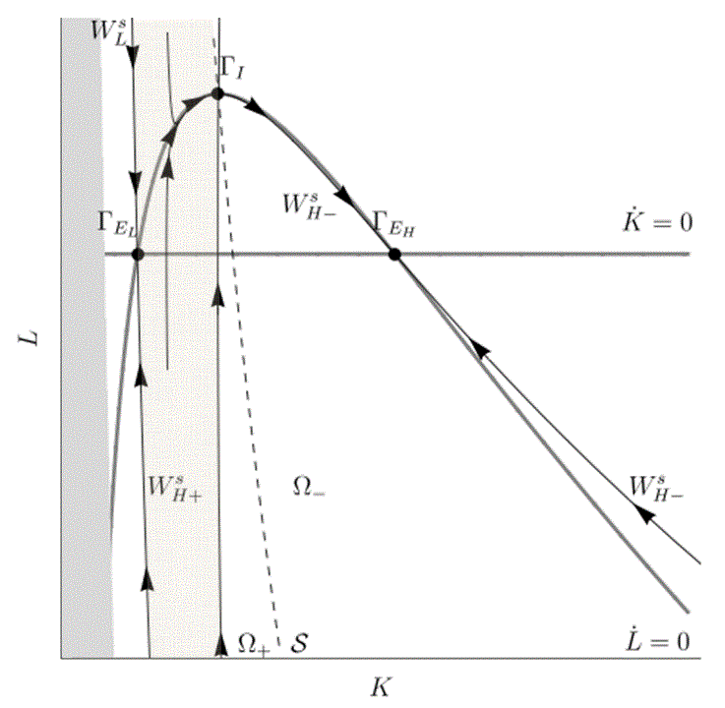

Figure – Phase diagram for the endogenous tax rule model.

Notice that I used the style Caption so we can build an automatic Table of Figures.

## .. Quotations

Excerpts from others’ work should be used only when strictly necessary. Whenever used, it should be easy to identify their both presence in the text (using indentation and/or a different font) and their source.

For excerpts up to three lines, you can use the normal formatting of the body of the text e.g.: “as referred to by Rodrigues (2014), the final report is limited to a «maximum of 20 pages of text (…), including the table of contents.»”

Longer quotations should appear as follows:

Recent research has also emphasized the role of imperfect competition in explaining a host of issues in international trade and finance (...). Thus, while there plainly are many other important distortions in the economy, there is good reason to believe that imperfect competition is one of the more important issues.

In: Obstfeld & Rogoff (1996), p. 689.

Unacknowledged use of another’s work is **plagiarism**. This not only violates the most basic rules of academic work, but as a form of falsification (or in some very specific cases, usurpation) it is also subject to disciplinary penalties imposed by the higher education institution. It is also a civil crime with penalties ranging from a fine to 3 years in prison (doubled in the case of repeat offences).

## .. References

Given the complexity of managing a bibliographical database linked to a text, especially on a large scale, such as in a MFW or doctoral thesis, use of specialist software (e.g. BibTeX, EndNote, ProCite, Reference Manager) is highly recommended from the beginning[2]. Reference databases such as EconLit or the Web of Knowledge export their listings into most formats used by these programmes, thereby facilitating the construction of a bibliography.

For formats to be used in-text and in the reference list, please read Costa (2017). Remember that there must be a one-to-one correspondence between the set of in-text citations (e.g. Costa, 2017 used above) and the list in the post-textual section References (e.g. Costa, L. (2017). *Rules Governing the Presentation of Written Work at ISEG*. Mimeo ISEG.).

Costa (2017)

Obstfeld & Rogoff (1996)

**???**

In-text citations

Costa, L. (2017). *Rules Governing the Presentation of Written Work at ISEG*. Mimeo ISEG.

References

**???**

Ljungqvist, L. & Sargent, T. (2012). *Recursive Macroeconomic Theory*, 3rd edn. Cambridge Mass.: The MIT Press.

Figure 2 – In-text citations and the reference list.

Figure above shows two examples of the wrong way of citing your bibliographic references:

* If you cite Obstfeld & Rogoff (1996) in your text[3], then you have to list it in the References section.
* If you want to keep the book “Recursive Macroeconomic Theory” in your reference list, then you have to cite it in the text as “Ljungqvist & Sargent (2012)”.

# 3. Conclusion

This is the final section of the main text. The maximum length is 10 per cent of the textual part, i.e. 3.5 pages.

Here, you should present the results and (if applicable) your intentions for future research.

# References

This is the first section of your MFW’s post-textual part. Remember that the maximum length is 50 pages, including the pre-textual part (but not the cover, the first, and the blank page).

Costa, L. (2017). *Rules Governing the Presentation of Written Work at ISEG*. Mimeo ISEG.

Obstfeld, M. & Rogoff, K. (1996). *Foundations of International Macroeconomics*. Cambridge Mass.: MIT Press.

Rodrigues, C.F. (2014). *Seminário da Licenciatura em Economia: Normas de elaboração do relatório final*. Mimeo ISEG.

Romer, D. (2012). *Advanced Macroeconomics*, 4th Ed. New York: McGraw-Hill.

# Appendices

This is the place where you put everything that is important to understand your work, but it is not indispensable in the main text. Use them, but remember that pages used here are counting for the 50 page limit. Some useful advices about appendices:

* Do not reproduce databases in paper! Use a website to make it available.
* If you have too many graphs (e.g. impulse-responses in a VAR) put them here.
* For cumbersome mathematical derivations, use the appendices as well.

1. I used MathType for the equations below.
2. I did not use software here, so that this template could be read by everyone.
3. I did it above.